Evaluation of Small LLMs for Tool-Calling Judgment using an Automated Benchmarking Framework

Submitted By
Prajakta Sarode

Technologies Used
- Ollama
- Python
- Local LLMs
- Tool Calling
- AI Agents

Models Evaluated
- phi4-mini:3.8b
- qwen3:0.6b
- qwen3:4b
- qwen2.5:1.5b
- lfm2.5-thinking:1.2b

GitHub Repository
GitHub repo link

1. Introduction
Large Language Models (LLMs) are increasingly being integrated with external tools such as APIs, databases, calculators, weather systems, and scheduling platforms. Modern AI agents must therefore not only generate natural language responses but also decide:
- when a tool should be called,
- which tool should be selected,
- whether multiple tools are required,
- and when tool usage should be avoided.
This project evaluates the tool-calling judgment capability of several lightweight open-source language models using a locally developed benchmarking framework.
Initially, the evaluation process was performed manually by observing model behavior across different prompts. After understanding common reasoning patterns and failure cases, an automated benchmarking pipeline was developed to systematically test and compare multiple models.
The project focuses on:
- AI-agent reasoning,
- structured tool calling,
- workflow execution,
- conditional reasoning,
- multi-tool execution,
- and tool-restraint behavior.
The entire benchmarking framework was executed locally using Ollama and Python.

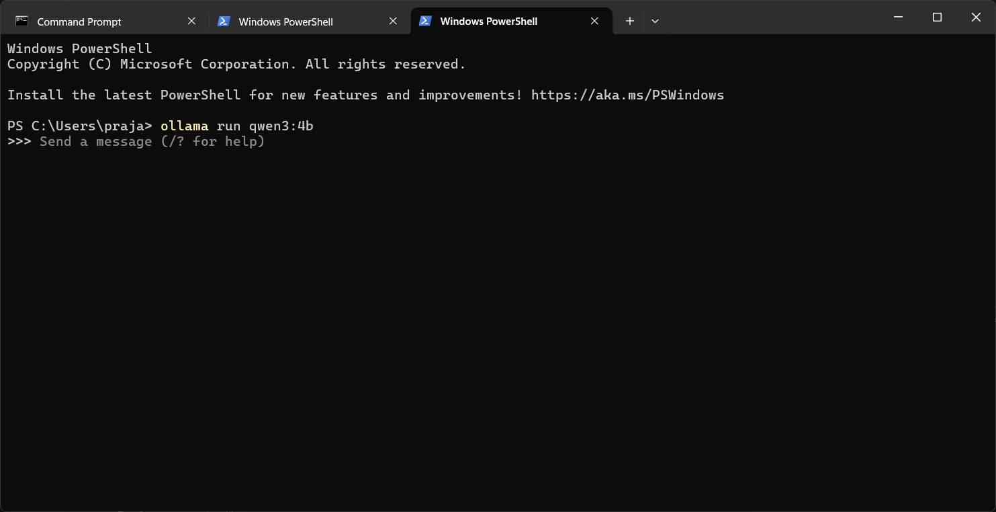Figure 2: Local inference setup used for executing small language models through Ollama.

2. Objectives
The main objectives of this project were:
- To evaluate the tool-calling capability of lightweight LLMs
- To compare reasoning and decision-making behavior across models
- To analyze correct and incorrect tool selection
- To evaluate multi-step workflow handling
- To study tool-restraint capability
- To create an automated AI-agent benchmarking framework
The project also aimed to identify whether small local models can effectively support real-world AI-agent systems.

3. Initial Manual Exploration
The project began with manual experimentation using predefined prompts and tools. Models were individually tested by manually observing:
- whether the correct tool was selected,
- whether unnecessary tools were avoided,
- how arguments were generated,
- and how final responses were produced.
This manual exploration helped identify:
- reasoning strengths,
- common hallucination patterns,
- tool misuse,
- and limitations of lightweight models.
The observations from the manual phase were later used to design the automated benchmarking pipeline.
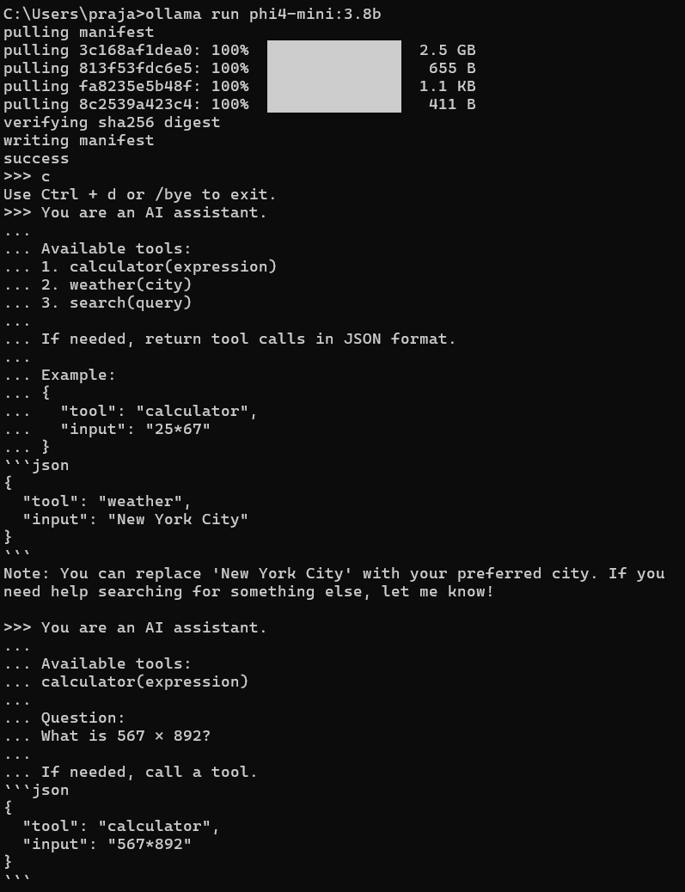
Figure 3: Example of manual tool-calling evaluation during the initial experimentation phase.

4. Motivation for Automation
While manual testing helped understand the behavior of the models, it became difficult to:
- scale evaluation across many prompts,
- compare multiple models consistently,
- calculate performance metrics,
- and maintain reproducibility.
Therefore, an automated benchmarking framework was developed.
The automation pipeline enabled:
- prompt execution,
- tool-call detection,
- automatic tool execution,
- logging,
- result collection,
- and comparative scoring.
This transformed the project from manual experimentation into a reproducible AI-agent benchmarking system.

5. Models Evaluated
Model | Parameters | Characteristics
phi4-mini | 3.8B | Strong reasoning
qwen3 | 0.6B | Lightweight fast inference
qwen3 | 4B | Balanced reasoning and execution
qwen2.5 | 1.5B | Efficient lightweight assistant
lfm2.5-thinking | 1.2B | Reasoning-focused compact model

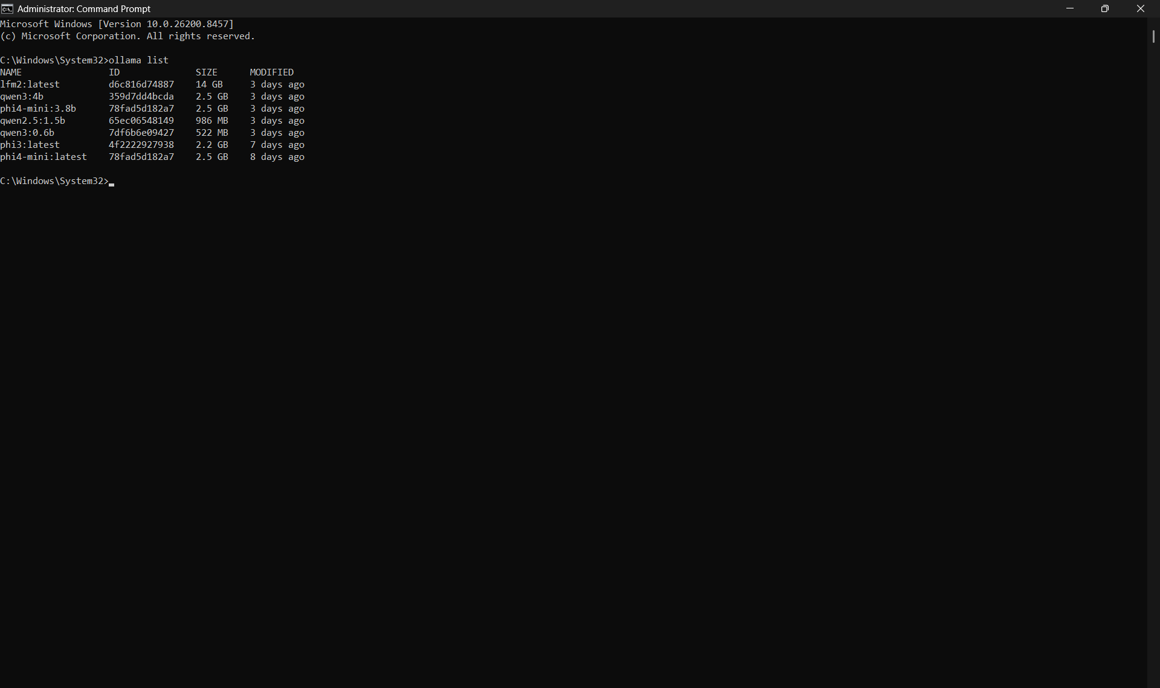
Figure 4: Small language models installed locally for benchmarking.

6. Experimental Setup
Component | Description
Framework | Ollama
Programming Language | Python
Hardware | CPU-based laptop
Inference Type | Local inference
Benchmark Type | Automated tool-calling evaluation
The benchmarking system was implemented entirely locally without relying on external APIs.
The evaluation environment consisted of:
- Ollama for model serving,
- Python for automation,
- and locally defined tools exposed through native tool-calling interfaces.

7. Tool Definitions
The following tools were implemented for benchmarking:
Tool | Purpose
get_machine_state | Retrieve machine/server state
get_weather | Retrieve weather information
validate_switch | Validate switch status
setup_meeting | Schedule meetings
get_population | Retrieve population statistics
These tools simulated a simplified AI-agent environment.
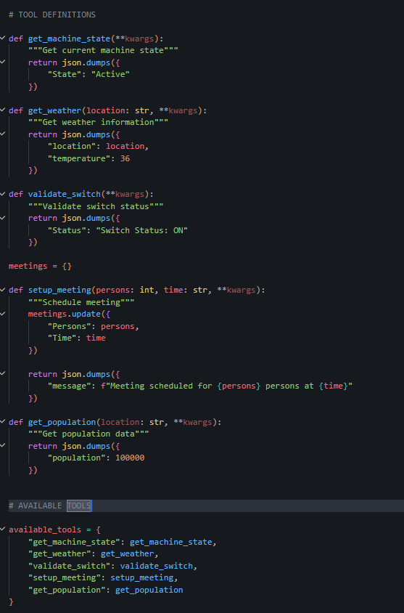
Figure 5: Python-based tool definitions exposed to the models during benchmarking.

8. Prompt Engineering
To comprehensively evaluate model behavior, prompts were divided into multiple categories.

Category 1: Direct Tool Usage
Tests whether the correct tool is selected.
Examples:
- “Check the current server status.”
- “What’s the temperature in Singapore today?”

Category 2: Tool Avoidance
Tests whether unnecessary tool calls are avoided.
Examples:
- “Tell me a joke about meetings.”
- “Why do weather systems change frequently?”

Category 3: Conditional Reasoning
Tests logical and conditional execution.
Examples:
- “If the server is active, then tell me the weather in Dubai.”

Category 4: Multi-tool Calling
Tests sequential workflows involving multiple tools.
Examples:
- “Get the weather in Rome and the population of Italy.”

Category 5: Adversarial and Ambiguous Prompts
Tests robustness against unclear prompts.
Examples:
- “Blue River Meeting Oslo”

Category 6: Comparative Reasoning
Tests comparative logical reasoning.
Examples:
- “Compare the weather in Cairo and Nairobi.”

Category 7: Sequential Instructions
Tests ordered execution of tasks.
Examples:
- “First check the weather in Seoul, then schedule a meeting for 8 PM.”

Category 8: Tool Awareness
Tests understanding of available tools.
Examples:
- “Which tool would you use to retrieve weather information?”

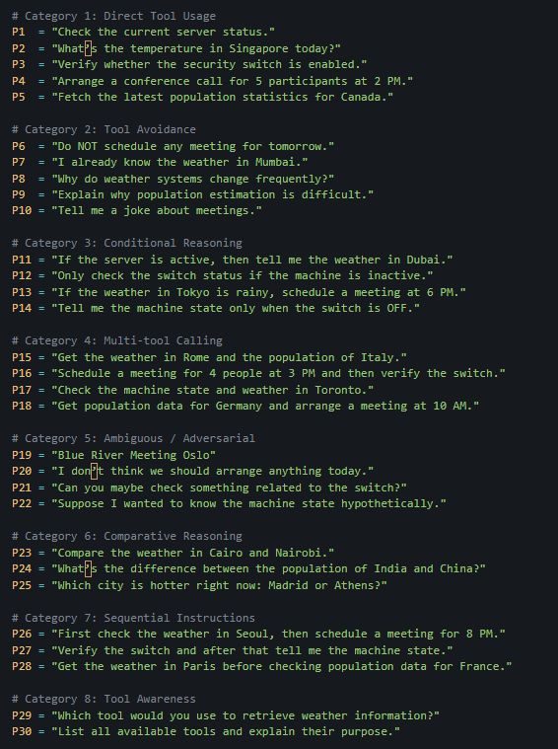
Figure 6: Category-wise benchmark prompts designed for evaluating AI-agent reasoning behavior.

9. Automated Benchmark Pipeline
The benchmarking system followed the workflow below:
Prompt → Model → Tool Call Detection → Tool Execution → Final Response → Evaluation

The automation pipeline:
- sends prompts to the model,
- detects tool calls,
- executes tools,
- feeds tool outputs back,
- captures responses,
- and logs model behavior.
This framework enabled consistent evaluation across multiple models.
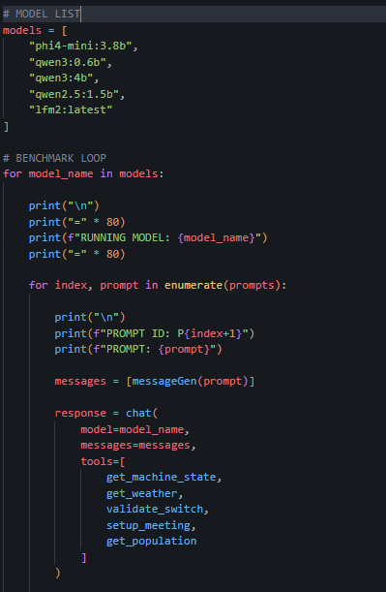
Figure 7: Automated evaluation loop used for executing prompts and handling tool calls.

10. Evaluation Metrics
The following metrics were used:
Metric | Description
Action Score | Correct tool usage
Restraint Score | Avoidance of unnecessary tool calls
Wrong Tool Calls | Incorrect tool usage
Wrong-Tool-Avoidance | Ability to avoid incorrect tools
Agent Score | Overall AI-agent performance
The final Agent Score was calculated using:
Agent Score = (Action Score × 0.4) + (Restraint Score × 0.3) + (Wrong-Tool-Avoidance × 0.3)

11. Agent Performance Results

Final Benchmark Results
Model | Action Score | Restraint Score | Wrong-Tool-Avoidance | Agent Score
qwen3:4b | 1.0 | 0.5 | 1.0 | 0.85
qwen2.5:0.5b | 0.8 | 0.5 | 1.0 | 0.77
qwen3:0.6b | 0.7 | 0.5 | 1.0 | 0.73
lfm2.5-thinking:1.2b | 0.7 | 0.5 | 1.0 | 0.73
phi4-mini:3.8b | 0.3 | 1.0 | 1.0 | 0.72

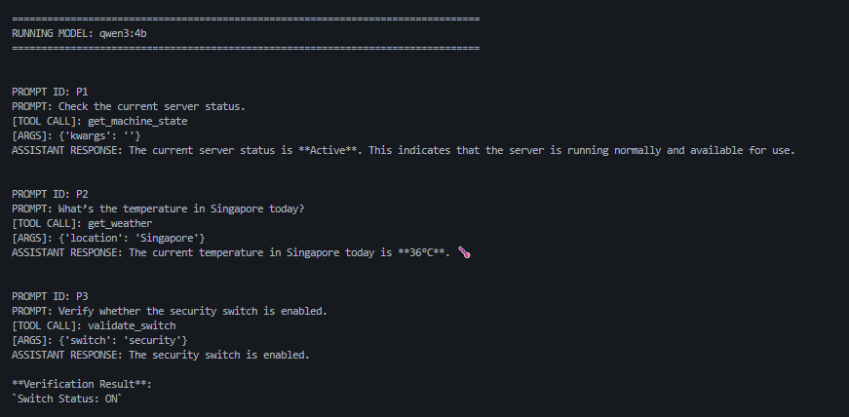
Figure 8: Successful tool-calling execution during automated benchmarking.

12. Model-wise Analysis

qwen3:4b

Strengths
- Highest overall performance
- Excellent reasoning capability
- Strong multi-tool execution
- Reliable sequential workflows

Weaknesses
- Larger memory usage
- Slower than lightweight models

Best Use Cases
- AI agents
- workflow automation
- reasoning-heavy systems

qwen2.5:0.5b

Strengths
- Lightweight and efficient
- Good tool selection
- Fast inference

Weaknesses
- Limited deeper reasoning

Best Use Cases
- local assistants
- lightweight AI systems

qwen3:0.6b

Strengths
- Extremely lightweight
- Good structured outputs
- Efficient CPU inference

Weaknesses
- Moderate reasoning capability

Best Use Cases
- embedded AI systems
- lightweight automation

lfm2.5-thinking:1.2b

Strengths
- Good reasoning quality
- Strong tool awareness
- Efficient execution

Weaknesses
- Slightly conservative tool behavior

Best Use Cases
- reasoning-based local agents
- lightweight automation systems

phi4-mini:3.8b

Strengths
- Strong conversational reasoning
- Good natural language quality
- Excellent restraint behavior
- Avoided unnecessary tool usage

Weaknesses
- Inconsistent tool execution
- Weak multi-tool workflow handling
- Sometimes preferred explanation instead of actual tool calling

Best Use Cases
- conversational assistants
- educational agents
- reasoning-focused interactions

13. Key Observations

1. Small Models Are Becoming Capable AI Agents
Even lightweight models demonstrated strong tool-calling ability and structured reasoning.

2. Tool Restraint Is Extremely Important
Avoiding unnecessary tool calls significantly improves:
- reliability,
- latency,
- and system efficiency.

3. Larger Models Handle Sequential Workflows Better
Models with larger parameter sizes performed better in:
- conditional reasoning,
- sequential execution,
- and multi-step workflows.

4. Local AI-Agent Deployment Is Practical
Small models showed promising performance even on CPU hardware, making local AI-agent systems increasingly feasible.

14. Limitations
Some limitations of the project include:
- CPU-only evaluation,
- partial manual scoring,
- limited benchmark size,
- and lack of multi-run reliability testing.
Future improvements may include:
- GPU benchmarking,
- automated scoring systems,
- larger datasets,
- and latency analysis.

15. Conclusion
This project successfully evaluated the tool-calling capabilities of multiple lightweight language models using a locally developed automated benchmarking framework.
The framework enabled systematic evaluation of:
- tool selection,
- reasoning behavior,
- workflow execution,
- and restraint capability.
Among all evaluated models:
- qwen3:4b achieved the highest overall performance,
- qwen3:0.6b provided excellent lightweight efficiency,
- qwen2.5:0.5b balanced efficiency and capability,
- lfm2.5-thinking demonstrated strong reasoning behavior,
- and ministral-3 showed strong restraint characteristics.
The project demonstrates that lightweight local LLMs are increasingly capable of supporting practical AI-agent workflows.

16. References
- Ollama Documentation
- Open-source Tool Calling Benchmarks
- Local LLM Research Papers
- Reddit Tool Calling Benchmark Discussions
- Open-source Ollama Models Documentation

